Keywords:
branding agency in Dubai, branding agency Dubai, Dubai branding agency, branding agency UAE, branding agencies in Dubai, branding agency services in Dubai
Meta Description:
This guide will help you understand everything related to branding and branding agency in Dubai, UAE. From definition to the selection process, learn everything.
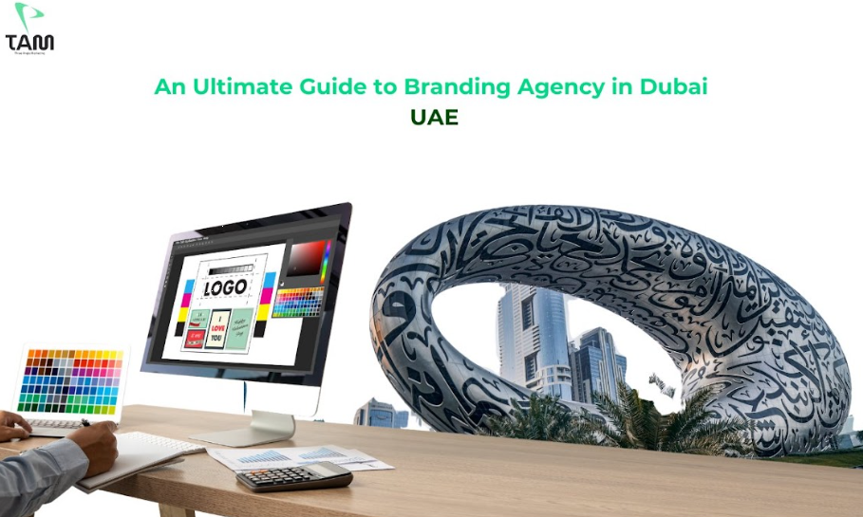

An Ultimate Guide to Branding Agency in Dubai, UAE
Have you ever wondered why customers choose a certain brand in the market? Or,
What factors did customers consider before selecting any particular brand in Dubai?
Branding is what helps customers to make a decision regarding purchasing decisions. Effective branding not only sets a brand apart from the rest of the competition but also adds more aesthetic value.
In Dubai, where competition is very high, the significance of branding in the growth of the brand is second to none.
Regardless of the size of your business, having knowledge of the best practices of branding is important.
In this comprehensive guide, we will discuss all the important aspects related to branding and branding agency UAE for an exceptional experience.
So, don’t stay behind and make branding a strong suit of your business. Read and learn how you can make this happen.

What is Branding?
Branding is the act of establishing a set of values attached to the product, service or its provider. That is all about having a story to tell your audience and making sure that your brand sticks out in the minds of the consumers.
Branding is not only limited to a company’s emblem and slogan but is the heart and backbone of it.
Brand building makes products easily recognizable by the users and buyers, making them develop a certain level of trust in the product.

Components of a Strong Brand:

The essential components of the brand foundation include;
- Brand Logo
- Brand Positioning
- Voice Consistency
- Distinctive Design
- Brand Identity
- Brand consistency
- Color Palette
- Typography
All the ingredients cumulatively define your brand in a way that is perceived in the marketplace.

Branding vs. Marketing: What’s the difference

Branding and marketing terms are not equivalent, but they sometimes are used synonymously. Whereas branding concentrates on establishing a perpetual message with the consumer, marketing is the short-run process of selling goods and services.

Why Branding Matters So Much in 2025?
Branding is continuously emerging as a critical path in the future of Dubai business in 2025.
As a result of using modern digital tools for media consumption, consumers are presented with numerous options.
Good branding keeps the needs of the customers in check, along with helping it to distinguish itself and create goodwill.
Branding is highly important in Dubai owing to the dynamic market environment.

The Future of Branding:
With the advancement in technology, it can be seen that branding is going to become more crucial.
In today’s world, competition is fast, and consumer behavior is fluctuating, a strong brand can be the winning tool.

The Role of Technology in Branding:
New-generation technologies, including AI and AR, have become very important in how companies communicate with consumers.
Keeping abreast with such trends should be necessary for brand sustainability in the future.

Building Trust and Loyalty:
Nowadays, with numerous similar offers on the market, the opportunity to gain and maintain the consumers’ trust is crucial.
These qualities can be developed with the help of a well-established brand to guarantee long-term achievement in the particular field.

What is Branding All About?
Branding has a lot of significance due to its effectiveness in generating more sales and promoting brand products and services.
Let’s discuss everything major about branding:

Storytelling is a great way to Connect with Audience:
Sharing of stories is a very effective way of passing a message or achieving a certain objective amongst the target audience.
In Dubai, the multiethnic environment fills the role of storytelling to enhance the communication between the people.
Make sure the story your brand has to tell should also be similar to and complementary to those of target consumers.

Adding an Element of Uniqueness to Brand Values:
Branding is all about making one or more brand values unique by adding one or more unique attributes.
In Dubai, it is essential for your brand to have an element of differentiation if you want your brand to thrive in the market.
This factor of differentiation can be achieved through inventiveness, superb customer relations, or a unique image.
Apart from that, originality also plays its part in creating an image that differentiates one company from another.

Make Brand Stories More Memorable for Customers:

This brings us to the third objective of branding, which is to make brand stories more memorable for the customers.
A good story leaves a powerful and unique experience and makes a brand popular among the people.
In one way or the other, you will notice that every brand has a story.
This story is created in such a way that it stays with the customer for many years to come.

Adapting to Change is a Great Way to Survive:

Survival is a primary instinct of living, and the same goes for brands.
Any brand in Dubai that wants to survive in the market must focus on flexibility. That’s where branding comes in. Whenever there is sustainability, there is a way to change to improve its chances of staying alive.
Branding helps brands adjust their approach in accordance with the current trends happening in the Dubai market and customers’ preferences.
Flexibility in the processes seems to be a governing attribute for branding in the dynamic environment of Dubai City.

Exclusive Branding Strategies Customize to Dubai:
Dubai is considered a hub of diversity and always demands a bespoke approach to upscale branding effectiveness.
Every branding agency in Dubai understands very well that a one-for-all strategy won’t work here.
That’s why it is essential to have exclusive branding strategies customized to Dubai.
Let’s discuss some of the most prominent strategies that help any brand to fit perfectly according to the requirements of Dubai City:

Respect Dubai Traditions
Dubai is full of so much cultural value that there is no scarcity of branding prospects in the Emirates.
Preserving cultural differences to bring appropriateness to the brand is significant to appeal to the target audience.

Language Matter More
As in any other cosmopolitan city, language is a weapon in Dubai, a multilingual state.

Adapting communication styles to different languages has the potential to greatly increase the understanding level of the brand. That’s why make sure your branding strategy doesn't ignore language.

Don’t Ignore Dubai's Diversity
Dubai is a city of immigrants that receives people from different cultures all over the world.
Brands that promote this aspect concerning race, color, and ethnicity may appeal to more people.
It is essential that you have multicultural-themed campaigns that incorporate the diverse cultures of the city.

Add More Flexibility to Approach
Every year, there are new developments and changes in the business sector in Dubai.
Flexibility can be defined as the ability to respond to change effectively, as it enables you to be agile when working on your brand.
Flexibility in approach is your ace in the sleeve that helps your brand to survive even in the face of tough competition.

Try to Connect on a Personal Level
The personal approach is effective in branding.
So, make sure you create messages that cause people to feel valued and significant.
For better results, you can rely on data analysis to interact with your customers on a personal level.

How to Boost Your Branding Strategies?
Here are some factors you need to consider if you want to boost your branding strategies in the most effective ways.

For better understanding, let’s discuss these factors in more detail:

Think Strategically:
Like all other brands, a great strategy forms the foundation of every great brand.
The sophistication of goals, awareness of targeted customers and establishment of the uniqueness of the brand are some factors you need to think about strategically.
For better outcomes, it is extremely important for a Dubai brand to define its markets very well due to its high diversity.
You should start with strategies, decisions, and actions as a guideline for all your branding processes.

Craft Engaging Content:
In the present context, content is king, and there are no two opinions on it.
So, make sure you craft engaging content that will hook your target market very well and is consistent with the tone and ideas of your brand.
The goal is to use compelling content and engaging images in all social posts and websites to make them enlightening and enjoyable.
In an age when people spend most of their time behind the screen, the audience tends to lose focus easily. That’s why it is where captivating content comes in handy.

Optimize Search Engine:
Visibility is important for the survival of any business in Dubai. The more visibility, the more attention, and the more customers.
Search engine optimization makes sure that the website shows up high in various search engines. This will ultimately bring a lot of traffic to your site through organic means.
For perfect results, try to incorporate proper keywords in your website, do optimization properly, and achieve good backlinks.
Through a good SEO strategy, you can promote and bring your brand to the top of search engine results with ease.

Don’t Overlook Social Trends
One of the greatest tools that businesses need to embrace in the process of establishing their brands is social media.
Use the best trending platform that is commonly used by your audience.
So, whether it is Instagram, Twitter or LinkedIn, ensure that you have selected the right channel to interact with the public.
Due to the extensive use of social media among the residents of Dubai, it is possible to use social media to promote the brand.

Add More Consistency into Branding
Consistency builds recognition. It is crucial that your brand message looks and feels good regardless of the platform it is shared.
Brand identity is essential to a company’s image because it brings consistency to branding and increases the confidence of the customers.
Consistency is your key to brand image in Dubai’s fast-rising economy if you want your business to survive in the highly competitive environment of Dubai.

Be Accessible All the Time

Accessibility is all about being available to the audience at any one time when they feel like it.
Accessibility is a perfect way through which you can engage your customers through the website using social media accounts, emails, and Live Chat services.
In Dubai, the operating business hours can go up to the late hours of the night. Therefore, being accessible 24/7 in the city makes customers happy.

Do and Don’t of Branding:
Here are some do and don’t about branding that helps you make better decisions:

Do's:
Communicate About Yourself: You need to communicate your brand's overarching values, missions, and visions in a better way.
Consistency: It is important to maintain the brand message relevance across all the interfaces.
Interact with Your Customers: You should positively interact with your customers and know them on a personal level.
Stay True: You should remain anchored to your brand reputation.

Don’ts:
Don’t Be Too Much Promising: As a way of working on trust, make sure that you do not over-promise in dealing with your stakeholders.
Do not disregard feedback: It is essential to consider what the customers are saying and improve based on that.
Avoid shift: All the materials that denote marketing should be in line with the brand.
Engage in Change: Don’t be afraid to change, especially when your brand shows growth and expansion.

How to Select the Right Branding Agency in Dubai?
Choosing the right branding agency in Dubai is definitely one of the most critical strategic decisions regarding your business. Here are the key steps to follow:
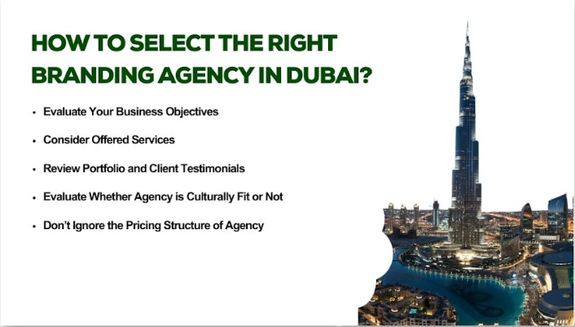

1. Evaluate Your Business Objectives
It is advisable to determine what you want to accomplish out of your branding activities. Your aims may include goals such as raising brand recognition, expanding to new channels, or rebranding.
When you set these goals, you will be able to select the right branding agency in Dubai, UAE.

2. Consider Offered Services:
Try to find branding agencies in Dubai that provide full-service marketing, specifically in the digital marketing domain. This can include:

- Social Media Marketing
- Content Creation
- SEO and SEM
- Web Design and Development
- Video Production and Branding

Make sure branding agency services in Dubai fit perfectly in your branding plan and contribute to the attainment of your business goals.

3. Review Portfolio and Client Testimonials
The portfolio of a potential branding agency, Dubai, is, in fact, an insight into their work area and their approach toward work.
It is for this reason that you should review the work of any agency you are going to select and check whether their work matches the kind of work that you want done.
Also, to get information about the agency’s reliability, you can consider client testimonials.

4. Evaluate Whether Agency is Culturally Fit or Not
Cultural awareness of the target market will help the Dubai branding agency develop relevant branding strategies for Dubai’s population.
Make sure that the agency you are going to work for possesses certain experience of operating in Dubai and knows how to work within Dubai's cultural background.

Don’t Ignore the Pricing Structure of Agency:
In general, price should not be the primary filter, but it is reasonable to know more about the prices and how they are set.
This is where you should make sure that you select the service providers with the most transparent price.
This way, you can make sure that you are willing to spend the right amount within your budget to get maximum value for your money.

Final Thoughts:
It is very important when you are making a decision to hire a branding agency in Dubai. So, you should do it wisely. When you are going to screen branding agencies available for hiring based on the following criteria as your business objectives, the digital marketing services to be offered, perusing through portfolios, and understanding their cultural and pricing fit, you can make a well-informed decision.
At Three Angle Marketing, we offer expert branding services customized to the diverse needs of your brand. Our branding strategist will assist you in developing a unique brand identity that is unique in the saturated Dubai market.
Get in touch with us for a new brand today!

Image 1:
An Ultimate Guide to Branding Agency in Dubai, UAE

Image 2:
Components of a Strong Brand:
- Brand Logo
- Brand Positioning
- Voice Consistency
- Distinctive Design
- Brand Identity
- Brand consistency
- Color Palette
- Typography
Image 3:
How to Boost Your Branding Strategies?

- Think Strategically
- Craft Engaging Content
- Optimize Search Engine
- Don’t Overlook Social Trends
- Add More Consistency to Branding
- Be Accessible All the Time
Image 4:
How to Select the Right Branding Agency in Dubai?
- Evaluate Your Business Objectives
- Consider Offered Services
- Review Portfolio and Client Testimonials
- Evaluate Whether Agency is Culturally Fit or Not
- Don’t Ignore the Pricing Structure of Agency

